6A – Driving – Lesson 06
Cost & Purchase of Insurance – Buying a car.

Name: _________________
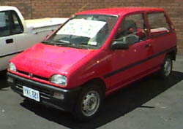
- Use Redbook to find the value of a 1989 Subaru Sherpa. (Not the private sale price).

- If you had a $1000 deposit how much would you have to borrow?

- How much stamp duty will need to be paid on transfer of registration?
  - 3% of the market value up to $45,000
  - 5% on the value over $45,000.

- How much will the CTP green slip cost? [www.prices.maa.nsw.gov.au]

- Using the answer to question 2 find the best loan over 3 years with a fixed interest rate.
www.infochoice.com.au/personal-loans/car-loan/interest-rate-comparison/

Loan Amount = $ _______ Interest Rate: = ____% Period = 3 years

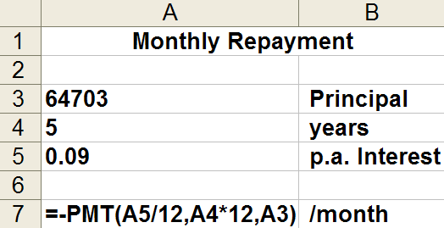
- Type in the spreadsheet below and find the monthly repayment.

Monthly Payment = $ ________

- Use the value in question 1 to get two quotes for Comprehensive insurance.

  - www.iselect.com.au/car/

  - www.nrma.com.au/car-insurance/comprehensive/

- How much would third party insurance cost? http://prices.maa.nsw.gov.au/

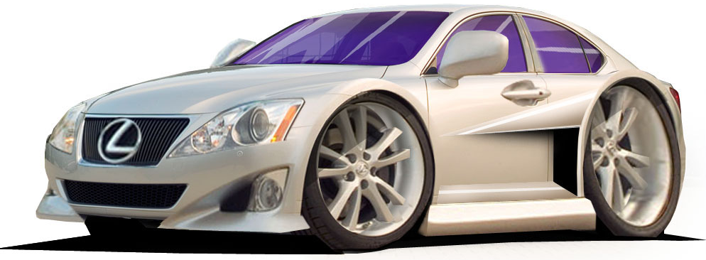
- What is the car of your dreams? Find out how much it will cost you to buy?

- If you had a $9,000 deposit how much would you have to borrow?

- How much stamp duty will need to be paid on transfer of registration?
  - 3% of the market value up to $45,000
  - 5% on the value over $45,000.

- How much will the CTP green slip cost? [www.prices.maa.nsw.gov.au]

- Using the answer to question 2 find the best loan over 3 years with a fixed interest rate.
www.infochoice.com.au/personal-loans/car-loan/interest-rate-comparison/

Loan Amount = $ _______ Interest Rate: = ____% Period = 3 years

- Type in the spreadsheet below and find the monthly repayment.

Monthly Payment = $ ________

- Use the value in question 1 to get two quotes for Comprehensive insurance.

  - www.iselect.com.au/car/

  - www.nrma.com.au/car-insurance/comprehensive/

- How much would third party insurance cost? http://prices.maa.nsw.gov.au/

